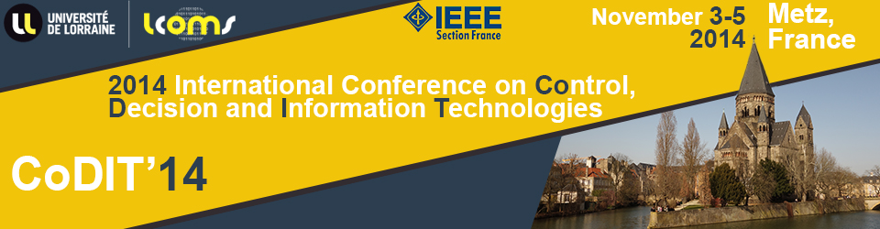

**Call for papers -- Special Session on:**

**Heuristics and Approximation Algorithms for Scheduling Problems**

**for CODIT2014**

**November 3-5, 2014 - Metz, France**

|  |
| --- |
| **Session chair**  **Prof. Imed Kacem, LCOMS Lab, Université de Lorraine, France** |
| *Session description*  *For several decades, the scheduling problems have constituted a privileged topic. Motivated by their industrial applications, several research teams studied these problems and proposed various models and resolution approaches. The aim of this special session is to present the recent heuristics and approximation algorithms in this field. Theoretical and practical works can both be submitted. Both works with applicative or theoretical aspects are encouraged. Topics of interest include, but are not limited to, the following topics:*  *Topics*  *► Scheduling theory*  *► Approximation algorithms and schemes applied to solve scheduling problems*  *► Heuristic and metaheuristic approaches*  *► Polynomial approximation*  *► Worst-case analysis of heuristics* |
| **Submission**  **Please submit your full paper or extended abstract of 2 to 3 pages choosing the right track on the Easychair site: https://www.easychair.org/conferences/?conf=codit14**  **June 20, 2014: deadline for paper submission**  **July 10, 2014: notification of acceptance/reject**  **September 10, 2014: deadline for final paper and registration.** |

